Your local TV station wants to create an AngularJS app for their programs guide page. The page displays information about the show’s airing time on the channel.

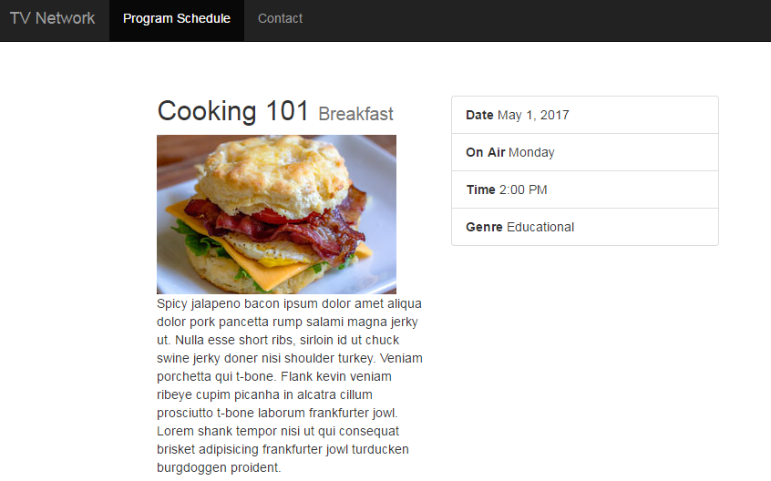

You will need to do the following:

1. Open your **app.js** file and create a new module named ***TVApp***.
2. Open the **index.html** file, and attach the ***TVApp*** module to the <body> element.
3. Create a new controller named ***MainController***.
4. In the controller create a new property called ***$scope.program***
5. Assign the following object to ***$scope.program***:

{ series: "Cooking 101",

img: "img/breakfast.jpg",

episode: "Breakfast",

genre: "Educational",

description: "Spicy jalapeno bacon ipsum dolor amet aliqua dolor pork pancetta rump salami magna jerky ut. Nulla esse short ribs, sirloin id ut chuck swine jerky doner nisi shoulder turkey. Veniam porchetta qui t-bone. Flank kevin veniam ribeye cupim picanha in alcatra cillum prosciutto t-bone laborum frankfurter jowl. Lorem shank tempor nisi ut qui consequat brisket adipisicing frankfurter jowl turducken burgdoggen proident.",

dateTime: new Date(2017, 3, 31, 14, 00, 00, 00)

}

1. Attach ***MainController*** to the <div> element with the class ***main***.
2. Use expressions to display the program details.